ISP Storyboard

Game starts with two splash screens, one for the company and the other for the game itself.

The user is greeted with a main menu, where they can choose a save file to create or load. They can also quit the game.

After creating a save file, they are greeted with a short message about the game and what it’s trying to promote (safe physical distancing). The game will then lead into the tutorial world.

First Level (Tutorial)

From this world, they will be able to access seven levels, each teaching a new mechanic of the game.

The italic text represents levels already concieved. Bolded represents levels fully modeled out.

|  |  |  |
| --- | --- | --- |
| Level # | Name | Basic idea of level |
| **1** | **Welcome** | Only uses the Young Adult type. |
| **2** | **Back to School** | Mostly uses the Student type. |
| **3** | **Family Friendly** | Mostly uses the Child+Parent type. |
| *4* | *Priority Seating* | Mostly uses the Elderly and Pregnant type. |
| 5 | Ramp Down | Uses the Disabled along with the Eldery and Young Adult type. |
| 6 | Day Pass | Uses the Grouped (Y.A only) along with the Child+Parent type. |
| 7 | Carry-on Baggage | Mostly uses the Large Luggage type along with the Student type. |

The user will not be able to advance until they have finished all of the levels in the tutorial. After this, they will be greeted with another message telling them they have finished the tutorial world. The game will automatically transition to the next level.

Second Level (Application)

Here, the user will see a similar world in which they can drive in. This world will be modeled after the real 94A route. The player will only have to solve puzzles on the 13 major stops. The levels will be amped up in difficulty, using different combinations of passenger types. After the user reaches the final destination, Ossington Station, the game will be over.

The color code represents levels “grouped” together. They use the same gimmicks/mechanic, giving each level a certain connection and a feeling that the user is learning.

|  |  |  |
| --- | --- | --- |
| Level # | Name | Basic idea of level |
| *1* | *Castle Frank* | Uses the PaC (Parent and Child) type to show its flexibility fitting in. |
| 2 | Parliament | Uses the PaC along with the Group type. |
| 3 | Sherbourne | Uses the Large Luggage type to show they only need to be touching one side of their luggage. |
| 4 | Jarvis | Uses the Large Luggage type to show luggage has a maximum size of 2x2. |
| 5 | Wellesley | Uses the past technique along with the Student and Disabled type. |
| 6 | Young | Use the glass on the bus to display that distancing rules do not pass through it. |
| 7 | Bay | Uses the past techniques along with Group (only YAs) and Large Luggage types. |
| **8** | **Queens Park** | Uses Students to display that backpacks are excluded from distancing. |
| **9** | **Kings Land** | Adds two Elderly types to the previous grid. |
| **10** | **Royal’s Paradise** | Uses the techniques taught in the past two levels along with the Disabled type. |
| 11 | Spadina | Shows that groups do not have to be made up of only Young Adults or PaC. Uses a mixture of Elderly, Pregnant, Young Adult, and PaC types. |
| 12 | Bathurst | Uses the Mixed Group type, mostly with Students and Large Luggage types. |
| 13 | Ossington (road) | Uses all the types and mechanics taught to fill up an empty bus. |

Puzzle Screen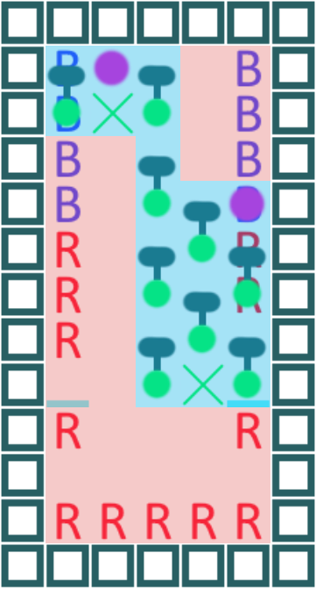

A working level design. The level is a 5 by 11 grid, where objects can be placed freely inside it.

The red outline represents places the user cannot place in. This will be filled with immovable passengers. The blue outline represents where the user can place in.

**B** and **R** represent priority seats and normal seats respectively. A purple dot is a Young Adult, a green dot is a Student. The extension is their backpack.

The current filled in passengers is one of the intended solutions.

The puzzle screen will have the grid on the right and the moveable objects to the left. The maximum amount of moveable objects will be 15.

Here is a working example of level 8, 9, and 10 respectively.